Konecranes delivered 13 Empty Container Handlers to DP World, Jebel Ali

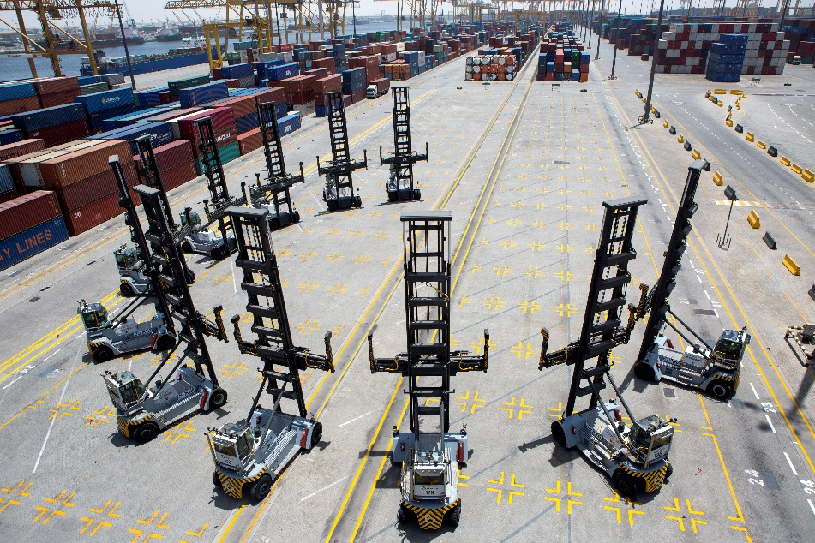
DP World received 13 Konecranes Empty Container Handlers at the beginning of 2016. The lift trucks are in full operation in DP Worlds flagship terminal in Jebel Ali, Dubai, UAE

DP World is an enabler of global trade with 77 marine and inland terminals across six continents. Jebel Ali Port, operated by DP World UAE Region, is the largest container terminal in the Middle East and the flagship facility of DP World’s portfolio. Expansions are currently underway, which will bring the total handling capacity to 22.1 million TEU by 2018.

For their ever increasing demands, DP World received their 13 Konecranes Empty Container Handlers (ECH) at the beginning of 2016.: “The order demonstrates Konecranes growing partnership with DP World globally and particularly in the Middle East. We are proud to be a supplier for DP World, a company who places a huge emphasis on quality and advanced technology,” says Abilash Kuvvakkat, Lift trucks Sales Manager Middle East.

The model SMV 7/8 ECC 90 Empty Container Handler can lift up to seven containers high thanks to its wide mast. All ECHs are equipped with Konecranes new driver cabin, featuring an increased visibility through lowered windows and eliminated corner posts. Furthermore, a seven-inch touchscreen color display provides full truck monitoring including eco-drive, fuel management and driver login. The touch screen monitor also provides the driver with an integrated rear-view camera and tire pressure monitoring.

In order to enhance the safety of the machines and the ability to act on maintenance requirements in a timely manner, TRUCONNECT® Remote Monitoring has been implemented on all ECHs. TRUCONNECT monitors everything from fuel consumption and traveling, to utility work, service actions, and critical events. It screens tire pressure, tracks impacts and shocks while continuously surveying the conditions of the hydraulic oil for optimal reliability and maintenance management.

“TRUCONNECT is a great tool to visualize and path track the DP World fleet, while text and email alerts for any irregularities help keep the fleet up and running with minimal interruption,” says Kuvvakkat.

Further information: Rebecca Nielsen, Marketing & Communication Manager, Konecranes Lift Trucks
Email: Rebecca.nielsen@koneranes.com or phone: +46 725 173 501

This press release together with a downloadable picture is available at our
website kclifttrucks.com

Konecranes is a world-leading group of Lifting Businesses™, serving a broad range of customers, including manufacturing and process industries, shipyards, ports and terminals. Konecranes provides productivity-enhancing lifting solutions as well as services for lifting equipment and machine tools of all makes. In 2015, Group sales totaled EUR 2,126 million. The Group has 11,600 employees at 600 locations in 48 countries. Konecranes is listed on Nasdaq Helsinki (symbol: KCR1V).

